Application-to-Person (A2P)

⚙️ What Is Application-to-Person (A2P) SMS?
# Source: Chatgpt (GPT-5-Mini) at [1/21/2026]
A2P SMS (Application-to-Person) is a type of text messaging where automated systems or applications send SMS messages to people’s mobile phones.
📩 It’s used when a system, not a human, sends messages to users or customers — like OTPs, alerts, reminders, and notifications.

🧠 In Simple Terms:
# Source: Chatgpt (GPT-5-Mini) at [1/21/2026]
If a company sends you a message like:
"🔐 Your one-time password is 746829"
— that’s an A2P SMS.

📲 Common Examples of A2P SMS:
# Source: Chatgpt (GPT-5-Mini) at [1/21/2026]
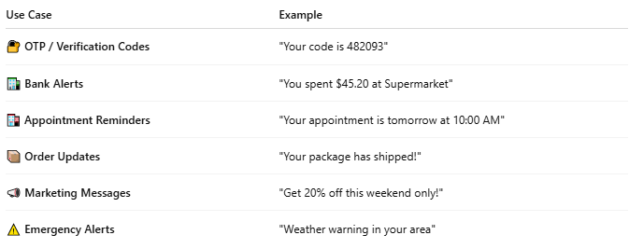

Use Case | Example
🔐 OTP / Verification Codes | "Your code is 482093"
🏦 Bank Alerts | "You spent $45.20 at Supermarket"
🏥 Appointment Reminders | "Your appointment is tomorrow at 10:00 AM"
📦 Order Updates | "Your package has shipped!"
📣 Marketing Messages | "Get 20% off this weekend only!"
⚠️ Emergency Alerts | "Weather warning in your area"

🧩 How A2P SMS Works:
# Source: Chatgpt (GPT-5-Mini) at [1/21/2026]
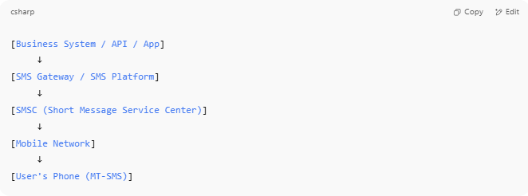

[Business System / API / App]
↓
[SMS Gateway / SMS Platform]
↓
[SMSC (Short Message Service Center)]
↓
[Mobile Network]
↓
[User's Phone (MT-SMS)]

The business app sends the message → routed via SMS gateway → delivered via mobile network.

🆚 A2P vs P2P SMS (Person-to-Person):
# Source: Chatgpt (GPT-5-Mini) at [1/21/2026]
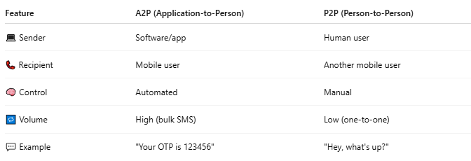

Feature | A2P (Application-to-Person) | P2P (Person-to-Person)
💻 Sender | Software/app | Human user
📞 Recipient | Mobile user | Another mobile user
🧠 Control | Automated | Manual
🔁 Volume | High (bulk SMS) | Low (one-to-one)
💬 Example | "Your OTP is 123456" | "Hey, what's up?"

🛠️ Technologies Used for A2P:
# Source: Chatgpt (GPT-5-Mini) at [1/21/2026]
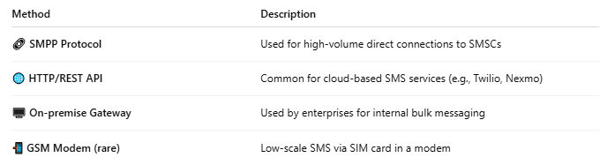

Method | Description
🔗 SMPP Protocol | Used for high-volume direct connections to SMSCs
🌐 HTTP/REST API | Common for cloud-based SMS services (e.g., Twilio, Nexmo)
🖥️ On-premise Gateway | Used by enterprises for internal bulk messaging
📲 GSM Modem (rare) | Low-scale SMS via SIM card in a modem

📖 Summary:
# Source: Chatgpt (GPT-5-Mini) at [1/21/2026]
A2P SMS is:
- 🧠 Sent by automated systems, not humans
- 📩 Received by mobile users
- 🛠️ Delivered via SMS gateways or APIs
- ✅ Widely used for alerts, authentication, and notifications

